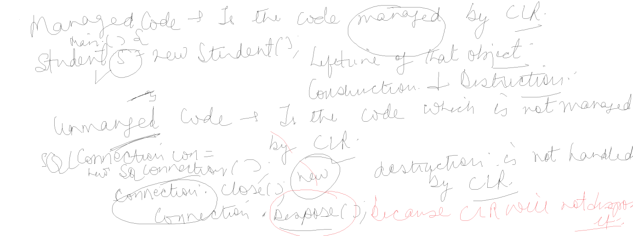

using System;

using System.Collections.Generic;

using System.Linq;

using System.Text;

using System.Threading.Tasks;

// Step 1

using System.Data.SqlClient;

using System.Configuration;

namespace ADODemos

{

class Program

{

static void Main(string[] args)

{

string choice = "y";

while (choice == "y")

{

int ch= Menu();

switch(ch)

{

case 1 : GetEmployees(); break;

case 2:

{

Console.WriteLine("Enter Name");

string name = Console.ReadLine();

Console.WriteLine("Enter Manager Name");

string managername = Console.ReadLine();

InsertRecord(name, managername); break;

}

case 3:

{

Console.WriteLine("Enter Id");

int id = Byte.Parse(Console.ReadLine());

DeleteEmployee(id);break;

}

case 4:

{

Console.WriteLine("Enter Id");

int id = Byte.Parse(Console.ReadLine());

Console.WriteLine("Enter Manager Name");

string managername = Console.ReadLine();

EditEmployee(id, managername); break;

}

case 5:

{

Console.WriteLine("Enter Id");

int id = Byte.Parse(Console.ReadLine());

SearchDepartment(id);

break;

}

}

//Console.WriteLine("Enter Id");

//int id = Byte.Parse(Console.ReadLine());

Console.WriteLine("Do you want to repeat");

choice = Console.ReadLine();

}

}

private static int Menu()

{

Console.WriteLine("Main Menu");

Console.WriteLine("1. List of Departments");

Console.WriteLine("2. Insert Department Record");

Console.WriteLine("3. Delete Department");

Console.WriteLine("4. Edit Department");

Console.WriteLine("5. Search Department");

Console.WriteLine("Enter Choice");

int ch = Byte.Parse(Console.ReadLine());

return ch;

}

private static string getConnectionString()

{

string connectionString = ConfigurationManager.ConnectionStrings["Myconnection"].ToString();

return connectionString;

}

private static SqlConnection GetConnection()

{

//string connectionString = "data source=LAPTOP-53S2KQS8;initial catalog=practicedb;integrated security=true";

SqlConnection connection = new SqlConnection(getConnectionString());

return connection;

}

private static void GetEmployees()

{

// Step 2

using (SqlConnection connection = GetConnection() )

{

// Step 3

using (SqlCommand command = new SqlCommand())

{

command.CommandText = "Select \* from department";

command.Connection = connection;

//SqlCommand com = new SqlCommand("Select \* from Employee", connection);

// Step 4:

connection.Open();

SqlDataReader reader = command.ExecuteReader();

if (reader.HasRows)

{

while (reader.Read())

{

Console.WriteLine(reader["id"].ToString() + " " + reader["name"] + " " + reader["managername"]);

}

}

reader.Close();

connection.Close();

}

}

}

static void InsertRecord(string name, string managername)

{

SqlConnection connection = GetConnection();

SqlCommand command = new SqlCommand("Insert into Department (name,managername) values(@name, @managername)", connection);

//command.Parameters.AddWithValue("@id", id);

command.Parameters.AddWithValue("@name", name);

command.Parameters.AddWithValue("@managername", managername);

connection.Open();

command.ExecuteNonQuery();

connection.Close();

command.Dispose();

connection.Dispose();

}

static void SearchDepartment(int id)

{

using (SqlConnection connection = GetConnection())

{

using (SqlCommand command = new SqlCommand())

{

command.CommandText = "Select \* From Department where id=@id";

command.Parameters.AddWithValue("@id", id);

command.Connection = connection;

connection.Open();

SqlDataReader reader = command.ExecuteReader();

if (reader.HasRows)

{

reader.Read();

Console.WriteLine(reader["id"].ToString() + " " + reader["name"] + " " + reader["managername"]);

}

reader.Close();

connection.Close();

}

}

}

static void DeleteEmployee(int id)

{

using (SqlConnection connection = GetConnection())

{

using (SqlCommand command = new SqlCommand())

{

command.CommandText = "Delete from department where id=@id";

command.Connection = connection;

command.Parameters.AddWithValue("@id", id);

connection.Open();

command.ExecuteNonQuery();

connection.Close();

}

}

}

static void EditEmployee(int id, string managername)

{

using (SqlConnection connection = GetConnection())

{

using (SqlCommand command = new SqlCommand())

{

command.CommandText = "update department set managername=@managername where id=@id";

command.Connection = connection;

command.Parameters.AddWithValue("@id", id);

command.Parameters.AddWithValue("@managername", managername);

connection.Open();

command.ExecuteNonQuery();

connection.Close();

}

}

}

}

}